4.WEB API Hands on

ASP.NET Core Web API – Hands-on 3
ASP.NET Core Web API – CRUD Operation (PUT)
1. Objective
- Demonstrate the use of the PUT action method to update employee data.
- Use the FromBody attribute to read data from the request body.
- Validate the employee ID and return BadRequest for invalid IDs.
- Test the API using Swagger and Postman.

Procedure / Implementation
Created a PUT action method in EmployeeController to update employee details. A hardcoded list of employees was used. The FromBody attribute was used to receive the employee object from the request body. If the employee ID was invalid or not found, a BadRequest response with the message "Invalid employee id" was returned. Otherwise, the employee details were updated and returned as the response.
Sample PUT Method
[HttpPut]
public ActionResult<Employee> Put([FromBody] Employee employee)
{
if (employee.Id <= 0)
return BadRequest("Invalid employee id");

var existingEmployee = employees.FirstOrDefault(e => e.Id == employee.Id);

if (existingEmployee == null)
return BadRequest("Invalid employee id");

existingEmployee.Name = employee.Name;
existingEmployee.Salary = employee.Salary;
existingEmployee.Permanent = employee.Permanent;
existingEmployee.Department = employee.Department;
existingEmployee.Skills = employee.Skills;
existingEmployee.DateOfBirth = employee.DateOfBirth;

return existingEmployee;
}

Verification Results
Test | Expected Result | Observed Result
Valid Employee ID | Employee updated successfully | Success
Invalid ID (≤ 0) | BadRequest – "Invalid employee id" | Success
Employee ID not found | BadRequest – "Invalid employee id" | Success
Screenshots
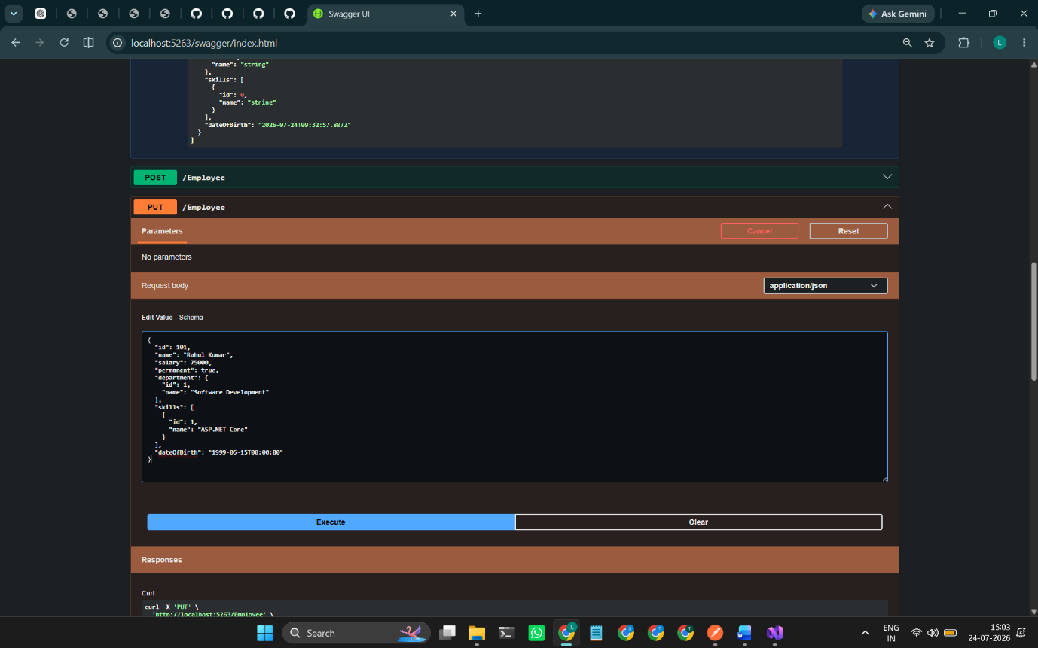
Figure 1: Swagger PUT Request (Valid Employee Data)
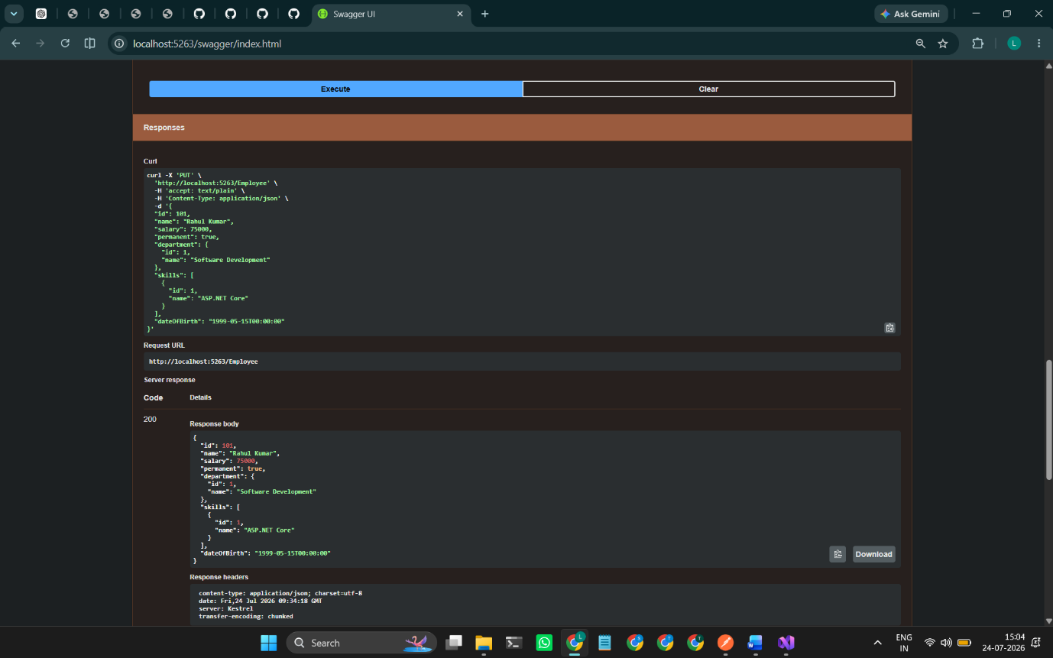
Figure 2: Successful Employee Update (200 OK)

Figure 3: Invalid Employee ID (ID ≤ 0)

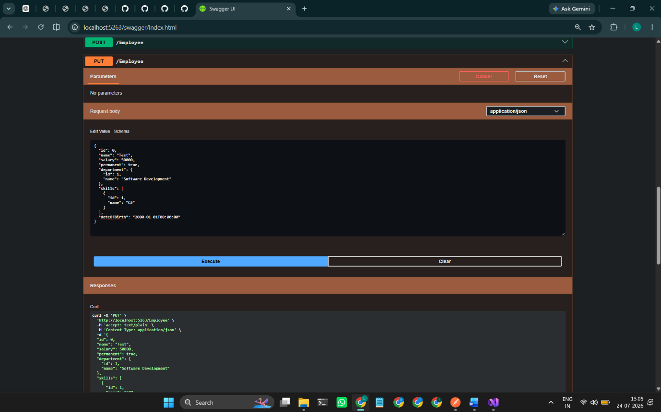
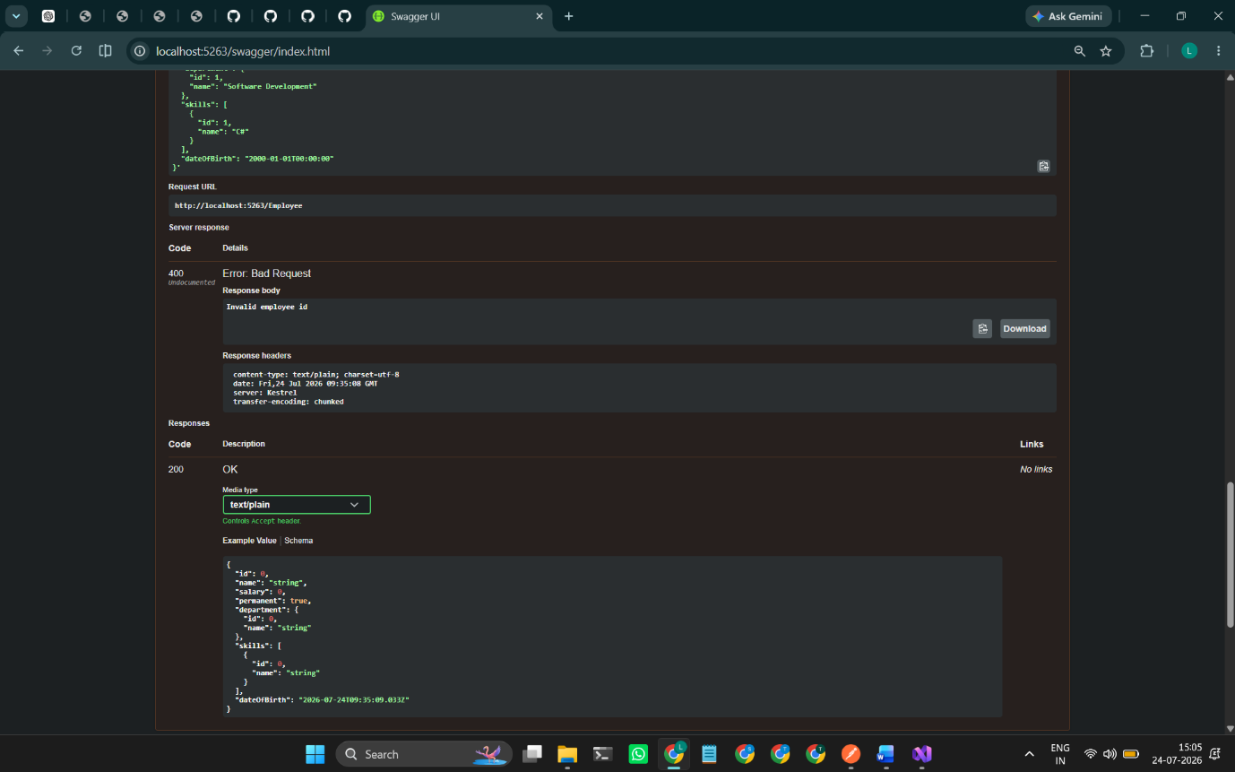

Figure 4: Employee ID Not Found
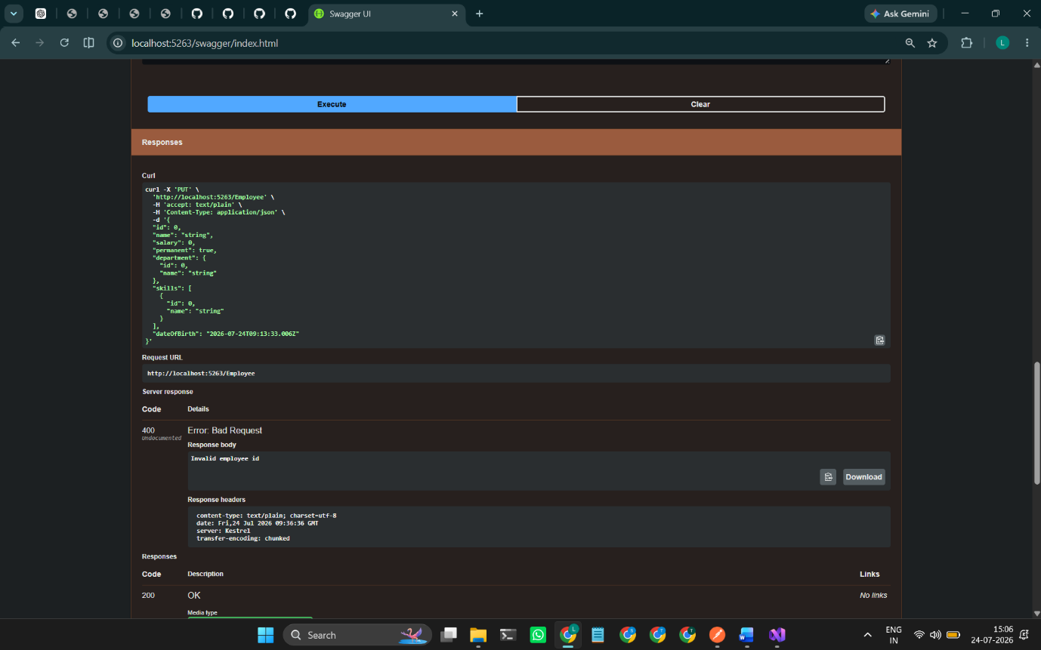

Result
Successfully implemented the PUT action method to update employee data using the FromBody attribute. Employee ID validation was performed, and appropriate BadRequest responses were returned for invalid IDs. The functionality was successfully verified using Swagger.

